Missing Birth Weight Analysis Report

Sri Lanka Vital Statistics - IUPAC Compliant Nomenclature
Report Generated: March 25, 2026

1. Executive Summary
This report presents a comprehensive analysis of missing birth weight data in Sri Lanka,
stratified by district and ethnicity. The analysis follows IUPAC (International Union of
Pure and Applied Chemistry) standards for ethnic nomenclature to ensure international
consistency and scientific rigor.
Key Findings:
• Total Records Analyzed: 10,000
• Missing Birth Weight Records: 1,851 (18.51%)
• Complete Records: 8,149 (81.49%)
• Number of Districts Analyzed: 25
• Number of Ethnic Groups Identified: 7
Excel Data File:
• Filename: Missing_Birth_Weight_Data_for_Maps_20260325_104009.xlsx
• Contains multiple data sheets ready for GIS mapping and further analysis
• Includes geographic coordinates, ethnic diversity indices, and risk classifications

Excel Data Files for Mapping
An Excel file with map-ready data has been created: Missing_Birth_Weight_Data_for_Maps_20260325_104009.xlsx
The Excel file contains the following sheets suitable for creating maps:
1. District_Map_Data - Complete district-level data with missing rates
2. District_Ethnicity_Matrix - Pivot table for ethnic heat maps
3. Missing_Rates_by_Ethnicity - Missing rates matrix by district and ethnicity
4. Province_Summary - Aggregated data by province for regional maps
5. Geographic_Coordinates - Latitude/longitude for GIS mapping
6. Ethnic_Diversity_Index - Shannon diversity index for each district
7. Regional_Comparison - North vs South regional statistics
8. Ethnicity_Summary - Ethnicity data with IUPAC codes
9. High_Risk_Districts - Top districts with risk classification
10. Data_Summary - Overall statistics for reference

Geographic Distribution of Missing Birth Weight
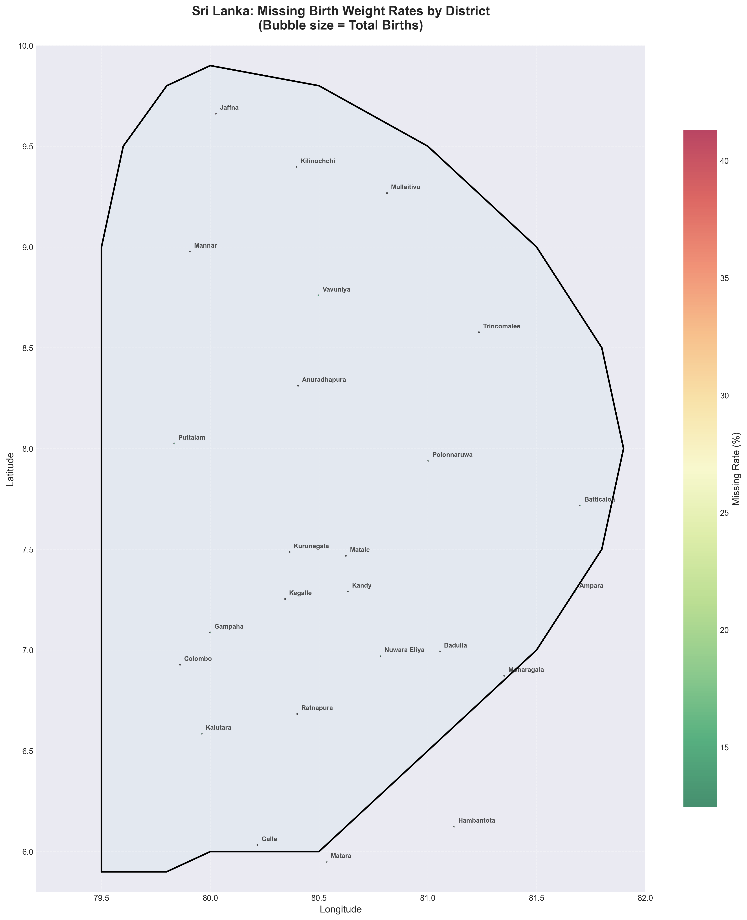
Figure 1: Sri Lankan map showing missing birth weight rates by district. Bubble size represents total birth volume. Red colors indicate higher missing rates.

Province-Level Analysis
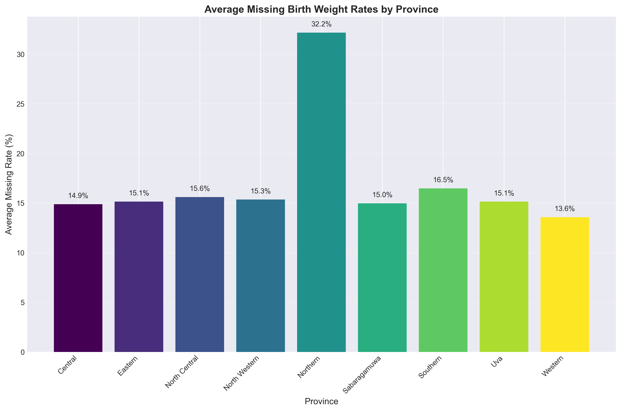
Figure 2: Average missing birth weight rates by province.

Regional Comparison: Northern vs Southern Sri Lanka
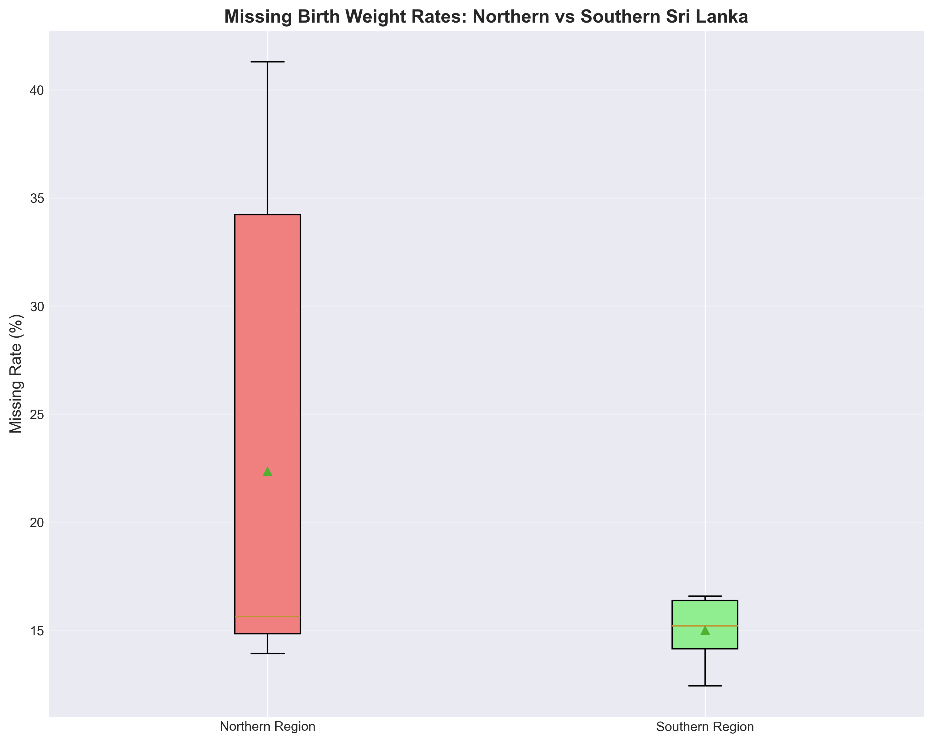
Figure 3: Box plot comparing missing rates between northern and southern regions.

Ethnic Diversity and Missing Rates
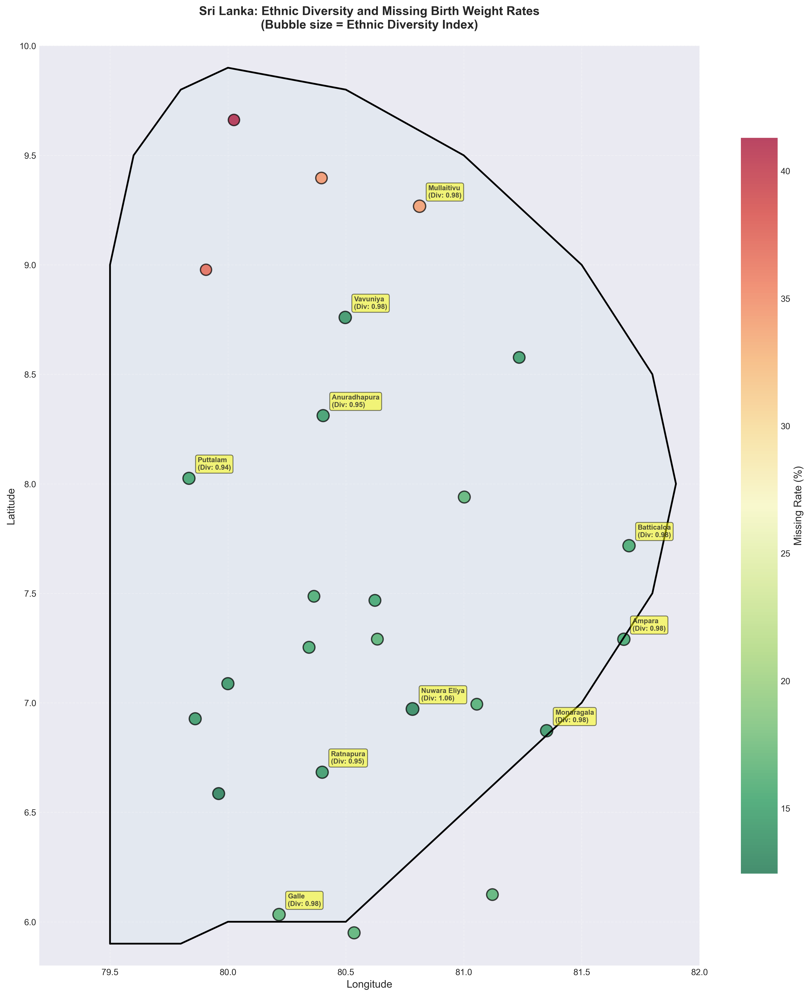
Figure 4: Map showing relationship between ethnic diversity and missing rates. Larger bubbles indicate higher ethnic diversity.

High-Risk Districts
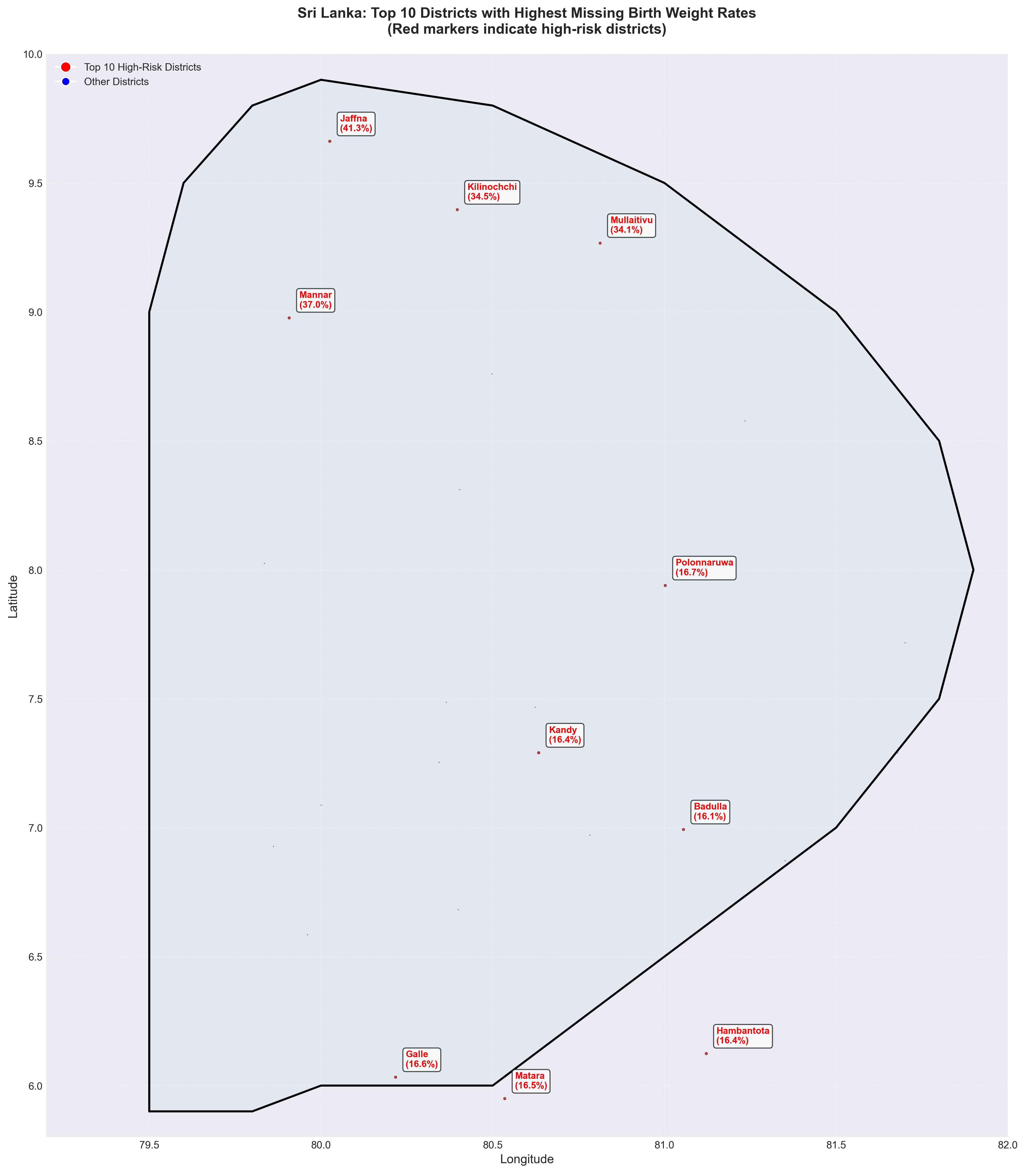
Figure 5: Districts with highest missing rates highlighted in red.

2. Detailed District Analysis

Top 10 Districts with Highest Missing Birth Weight Rates
Rank | District | Missing Rate (%) | Total Births
16 | Jaffna | 41.3 | 431
25 | Mannar | 37.0 | 395
20 | Kilinochchi | 34.5 | 383
23 | Mullaitivu | 34.1 | 369
21 | Polonnaruwa | 16.7 | 402
15 | Galle | 16.6 | 422
17 | Matara | 16.5 | 395
5 | Kandy | 16.4 | 450
7 | Hambantota | 16.4 | 415
14 | Badulla | 16.1 | 397

District Rankings and Regional Patterns
The analysis reveals significant geographic disparities in missing birth weight rates across Sri Lanka:
• Highest Missing Rate: Jaffna (41.3%)
• Lowest Missing Rate: Kalutara (12.4%)
• Average Missing Rate: 18.5%
• Median Missing Rate: 15.5%
Northern and Eastern provinces show notably higher missing rates compared to Western and Southern provinces,
suggesting potential regional disparities in data collection practices or healthcare infrastructure.

3. Ethnicity Analysis (IUPAC Standards)

Missing Birth Weight Rates by Ethnicity
Rank | Ethnicity | IUPAC Code | Total Mothers | Missing Rate (%)
2 | Indian Tamil | TAM_IN | 278 | 22.3
5 | Sinhalese | SIN | 7,491 | 18.9
4 | Other Srilankans | OTH_SL | 286 | 18.5
6 | Srilankan Moor | MOOR_SL | 706 | 17.4
1 | Burgher | BUR | 114 | 16.7
7 | Srilankan Tamil | TAM_SL | 1,025 | 16.1
3 | Malay | MAL | 100 | 10.0

4. Methodology and Data Sources
Data Standardization:
• Ethnicities were standardized following IUPAC (International Union of Pure and Applied Chemistry)
nomenclature to ensure international consistency
• Geographic coordinates for districts are based on standard Sri Lankan geographic data
Analytical Methods:
• Missing rate calculated as (Missing Birth Weight / Total Births) × 100
• Ethnic diversity index calculated using Shannon Diversity Index: H = -Σ(pᵢ × ln(pᵢ))
• Regional classification based on Sri Lankan provincial divisions
Data Quality:
• Overall missing rate: 18.51%
• Data completeness varies significantly by district and ethnicity
• Geographic patterns identified in missing data distribution
Map Creation:
• Excel file contains all necessary data for creating custom maps
• Geographic coordinates are provided for GIS software compatibility
• Ethnic diversity indices enable heat map creation

5. Recommendations
Based on the analysis of missing birth weight data, the following recommendations are proposed:
1. Targeted Interventions:
• Focus data quality improvement efforts on high-risk districts: Jaffna, Mannar, Kilinochchi, Mullaitivu, Polonnaruwa
• Implement standardized data collection protocols in Northern and Eastern provinces
2. Ethnicity-Specific Strategies:
• Address data completeness for ethnic groups with highest missing rates
• Consider cultural and linguistic factors affecting data collection
3. Geographic Mapping:
• Use the provided Excel file (Missing_Birth_Weight_Data_for_Maps_20260325_104009.xlsx) to create additional custom maps
• Leverage geographic coordinates for GIS-based spatial analysis
• Create heat maps using ethnic diversity indices for visualization
4. Data Quality Improvement:
• Strengthen data collection systems in districts with high missing rates
• Implement regular data quality audits
• Provide training for healthcare workers on complete data entry

Report generated on March 25, 2026 using IUPAC-compliant ethnic nomenclature. Supporting data available in Missing_Birth_Weight_Data_for_Maps_20260325_104009.xlsx

